 Destiny for your true companion

**COMEPEER APP REQUIREMENTS DOCS**

1. **Business Goals and App Overview**

* Mental health App which provides one stop solution for a person to cure his/her mental health need.
* We need an app in which we need 4 Main sections: Home, AILY, Peers, Expert
* **Home :** In this section we will have to showcase the user name, mental health index after taking self assessment tests based on various mental health issues, Blogs to read, Youtube videos section regarding mediation, mental health, journaling page(notes), etc.

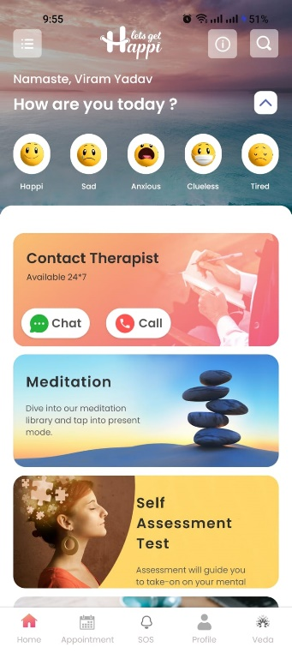 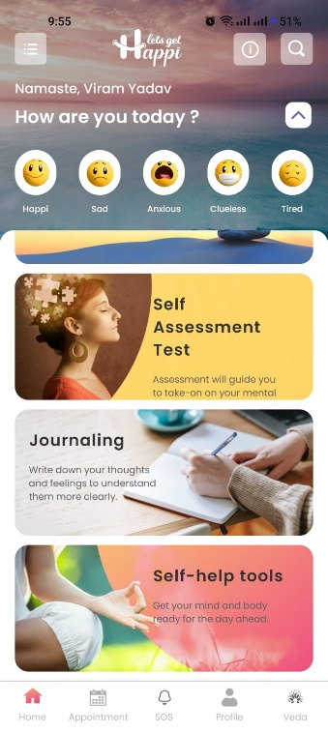

This screenshot is just for reference. We need this type of soothing colour app, and the fuctionalities which we mentioned on home page.

Our Theme colour Should Match our logo colour that is light blue. As well as calming effects.

In Homepage We need clickable sections of blogs and youtube videos . Just like the right side screenshot has(self help tools).

**Improvisation will always be there…**

* **AILY :** It is a chatbot which will talk to human just like normal being. At initial stage we will use openai api to make chatbot and named it as AILY(AI Loves You). This Section also we want on home page of the user just after login. It will be free for all. For ref you can refer to my ai of snapchat bot.
* **Peers :** In this section we will list our human listeners who are ready to talk, listen, interact with our users in exchange of some small amounts like 8rs/min… we will provide authority to human listeners to charge any amount, and user can decide whether they want to pay and talk or not. From User side it is simple, he just has to add money in his comepeer wallet then later he can use that coins for talking too human friend, or psychologist. **Why wallet ?** because once the money will be credited into wallet, the user will perceive it as coins not money, so just little psychological ease. In this same section we want a subsection in which any user can apply to become listener and earn money by being emotionally available for the person who needs. We will ask them 10 question and based upon that we will judge whether they are eligible to become a listeners on comepeer or not.
* **Experts :** This section is simple we will list our psychologists who can guide and consult them professionally on chat or video and charge according to them.

**BELOW ARE SOME PICTURES FOR REFERENCE.**

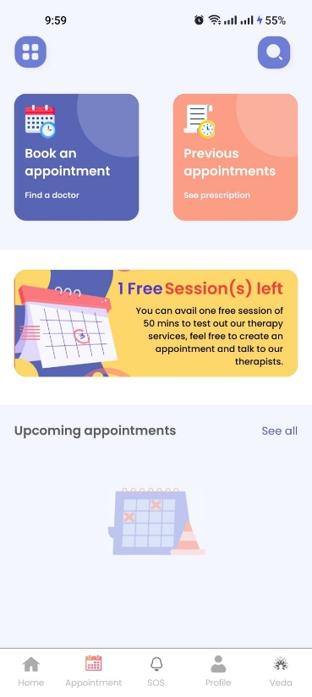 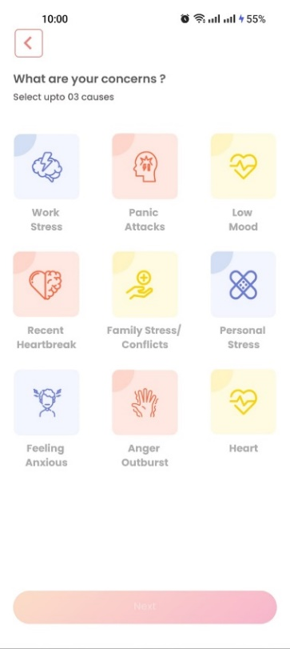 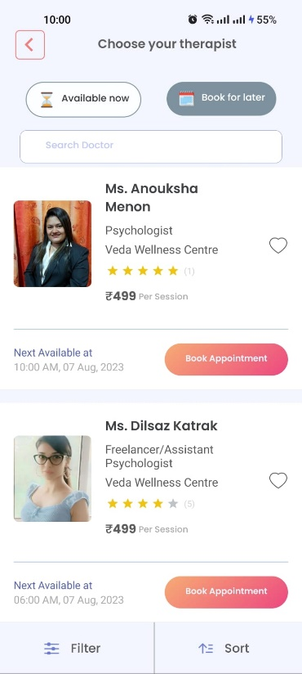

 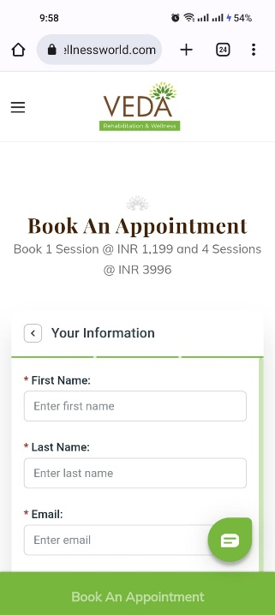 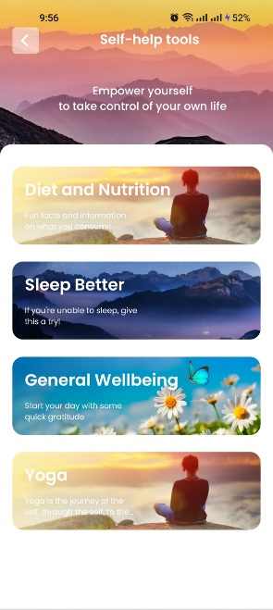

**Note :** *For more references you can download app of* ***clarity, lets get happi, yourdost.*** *No doubt they our comepetitors but for app development you can take idea from there app. Comepeer will win in different way.*

### App Technology and Infrastructure Requirements

### Android based app as of now. Later we will need ios as well.

### UI and UX should be in consider. User should feel calm will spending time on the app.

### User Journey

### Download & open the app -> Asking for permisions & notifications -> Login with OTP -> Setting up their profile -> Taking self assessment test for their mood and stress identification -> Exploring Home Page( Journaling section, videos, yogas, community, quotes, etc stuffs) -> Clicking on AILY and start talking to an Ai bot -> Adding money to wallet -> Using that money to pay and talk with peers( human listeners sharing the same experience) -> If they want to be anonymous then extra charge -> If they need more expert advice then they can come to expert section where psychologists can take -> Customer support and feedback page before exit and one question at one time of exit regarding improvements.

### 

### Monetization Model

### In app purchases

### Advertisement slots

### Subscription model at later stage

### Events tickets

### Offline yoga or rehab

### Watch ads to collect coins

### Affiliate links of products

### Budget & Our Offerings

### As we are a startup, instead of money we can give you 10% equity in our eminent transformational startup.

### Or else you are free to quote your amount to build an app we can negotiate on your demands